Hoofdstuk 13: samenvatting
Lees eerst het boek en gebruik dan deze samenvatting.
Bladzijdenummering niet 100% accuraat!

5) Muscles and animal movement
- Temperature & salinity ↑ → oxygen solubility ↓. Normoxic (100% saturated with oxygen), hypoxic (less oxygen).
- Deep water only oxygen if mixing.
- Maximize gas transfer: surface↑, diffusion distance↓. Small animals → surface area/volume large.
- Ventilation.
- Gas transport mechanism vertebrate has two pumps and two diffusion barriers. Gas transport: (1) breathing movements: continuous flow fluids, (2) diffusion O2 and CO2 across respiratory epithelium, (3) transport blood, (4) diffusion O2 and CO2 → mitochondria.
- Respiratory pigment ([O_{2,blood}]↓, 0,3%→20%): complex protein/metal ions, tetramic globin protein α₁β₁α₂β₂, all 1 heme group, Fe²⁺ in heme binds one O₂.
- Oxygen dissociation curves: %saturation ↔ pO₂. Heme subunit cooperativity: oxygenation 1st → others (tense → relax; sigmoïd curve: uptake & release ↔ pO₂).
- Variations oxygen affinity by variations globin protein. Temp↑, binding phosphate ligands, pH↓ (Bohr effect), CO₂↑ → haemoglobin-oxygen affinity↓ (CO₂ + H₂O → HCO³⁻ + H⁺; HCO³⁺ binds haemoglobin).
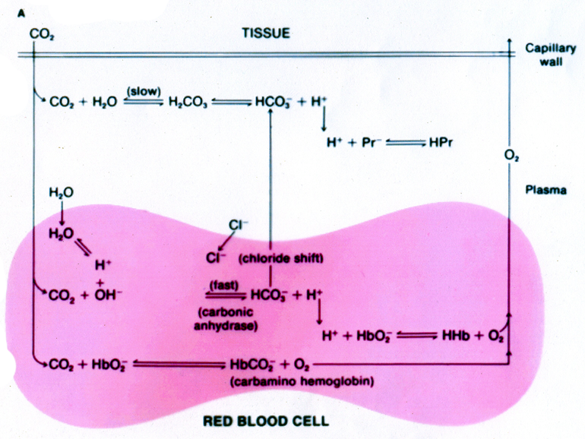
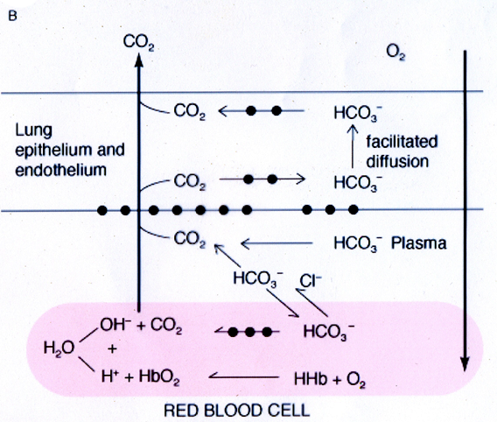
- (..) In some fishes, cephalapods and crustaceans root effect: CO₂↑ → capacity oxygen binding↓
- (CO₂ transport)
- (..)
- See table (at respiratory quotient 0.7 → no pH change blood). Lungs and bloodcells contains carbonic anhydrase.

In lungs | In tissues
- CO₂ afgevoerd als CO₂ of HCO₃⁻  - Also facilitated diffusion as HCO₃⁻ by CA in endo- and epithelium lungs.  - O₂ diffuses → red bloodcell  - Binds Hb, release H⁺.  - In bloodcell [H⁺ + OH⁻ → H₂O] by [HCO₃⁻ → OH⁻ + CO₂ (CA)] → OH⁻↑ and H⁺↑ | - CO₂ diffuses → red bloodcell  - CO₂ + H₂O → HCO₃⁻ + H⁺ (CA)  - CO₂↑ & H⁺↑ → release oxygen from Hb  - Chloride enters cell, HCO₃⁻ leaves cell (chloride shift).

  - – 544. (..)
- Water 1000x more viscous, ¹/₃₀x oxygen air.
- Lungs: Trachea, cartilage, main bronchi, bronchiole, terminal bronchiole, respiratory bronchiole, alveolar duct, alveolus, alveolar septum, pores of Kohn.
- Tidal volume, anatomic dead space volume (air inhaled nonrespiratory tubes), physiological dead space volume (anatomic + non-functional or too well ventilated alveoli).
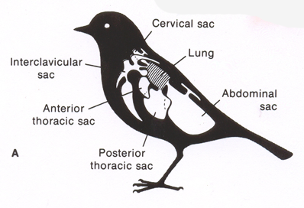
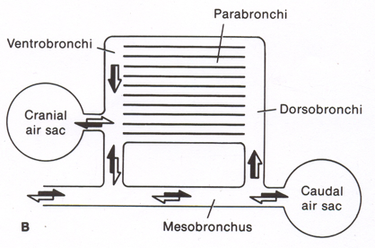
- Alveolar ventilation volume = tidal – anatomic. Max tidal = vital capacity.
- Gas levels determined ventilation and rate gas transfer. Ventilation determined breathing rate, tidal volume, anatomic dead space.
- Blood flows lung: Pulmonary circulation (pulmonary artery) and bronchial circulation (body). (..)
- (..) Lungs suspended pleural cavity, walls (thoracic cage) formed ribs and diaphragm, fluid filled sealed pleural space.
- (..)
- (..) Birds: gas transfer in small air capillaries that branche from parabronchi. Nomenclature (see right).
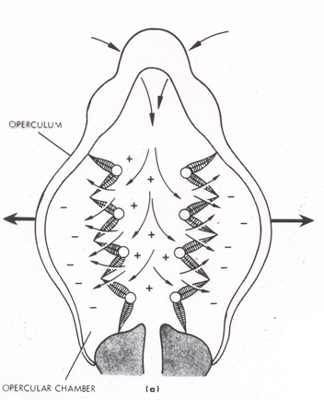
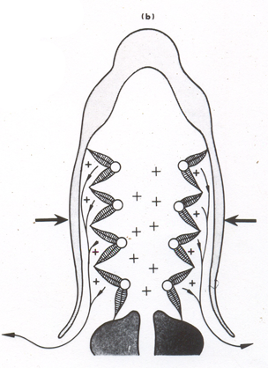
- During inhalation both sacs filled, during exhalation both sacs emptied, by aerodynamic valving (openings of dorsobronchi and ventrobronchi into mesobronchus direction-dependent resistance air flow) always unidirectional flow through parabronchi. (Reptiles, frogs)
- (Invertebrates, pulmonary surfactants, heat and water loss).
- (..)
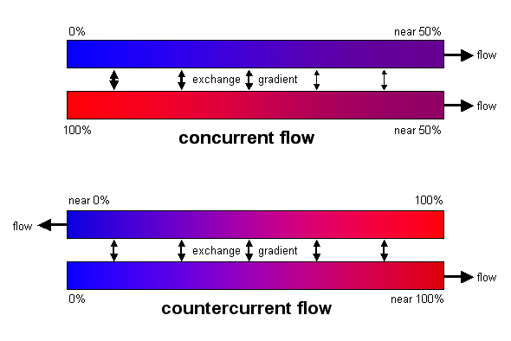
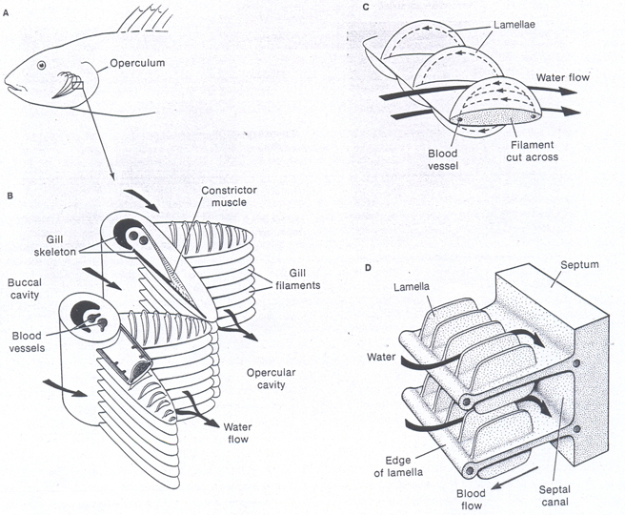
- Insects transport air through air-filled invaginations body surface: trachea. Entrances called spiracles, controlled (↔ water and dust). Tracheoles (terminal smallest branches → tissues). Also air sacs (storage and general balance). (..)
- – 559. (..)
- Gills: higher ventilation because lower O₂ content, unidirectional because E efficiency. Water drawn into mouth (buccal cavity) by muscles buccal cavity and operculum, passes over gills, exits through cleft operculum (both have valves). Pressure difference maintained → unidirectional flow maintained.
- ram-ventilate: ventilation through gills by opening mouth during forward motion.
- Countercurrent: ΔP_{O2} maintained→ more exchange (advantage if O₂content∙flow values close; usually waterflow fast, but more O₂ blood → advantage). Anatomy: 4 branchial arches, 2 rows dorsoventral flattened filaments, having upper and lower row lamellae. Covered mucuous layer protection and boundary water/epithelium.
- – 577. (..)

